**Kubernetes Assignment:**

**1.**Create a Pod called nginx-pod1 with image nginx (it runs on Port 80)

2. Create another Pod called tomcat-pod1 with image tomcat (it runs on Port 8080)

3. Access these pods on worker nodes (use curl command). Are you able to Access? If not then checkout the reason.

4. Go inside tomcat pod (use kubectl exec....command) and try to access nginx service Pod by using nginx-pod1 IP address and pod name. Are you able to access the nginx website? if no then figure out the reason.

5. Go inside nginx pod (use kubectl exec....command) and try to access tomcat service with IP address and pod name ot tomcat-pod1. Are you able to access the nginx website? if no then figure out the reason**.**

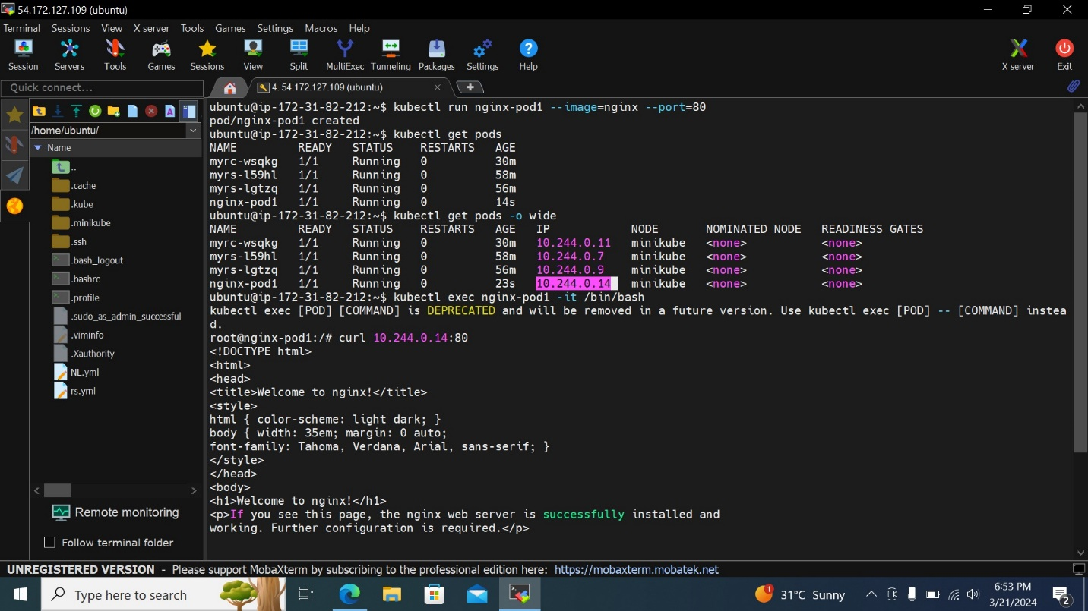

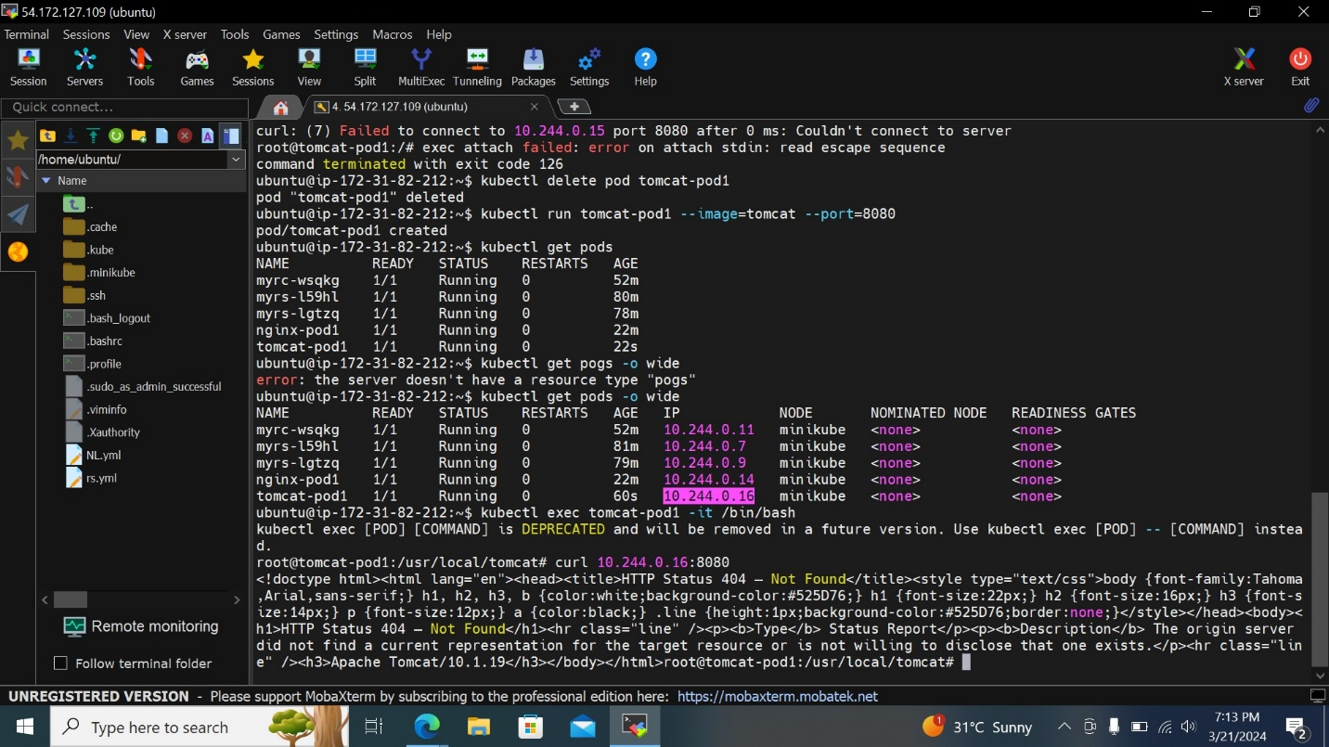

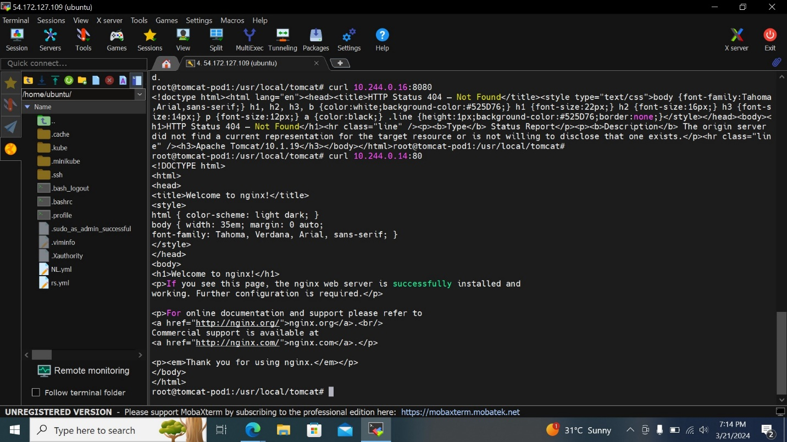

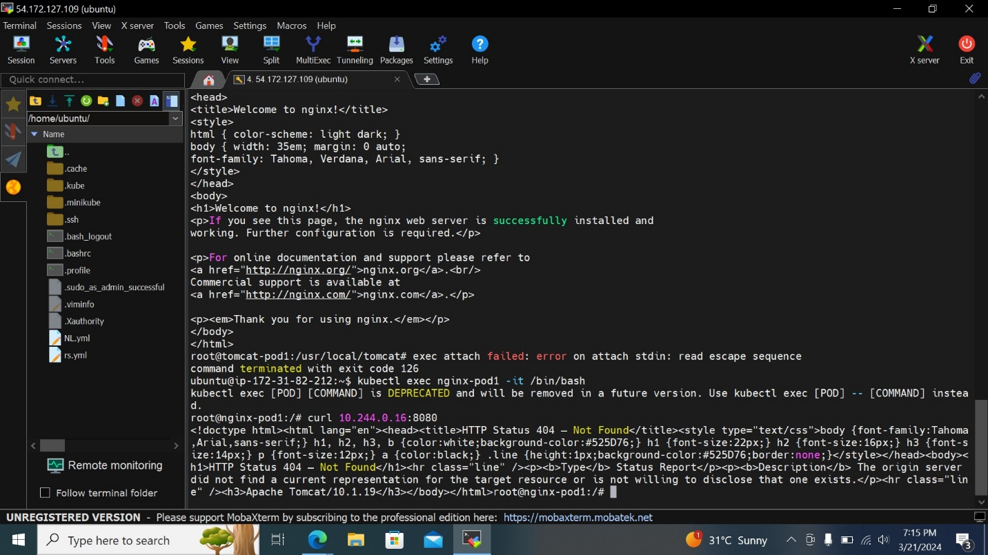

**6. Change docker image of nginx-pod1 from nginx to tomcat. Is it possible for running a pod?**

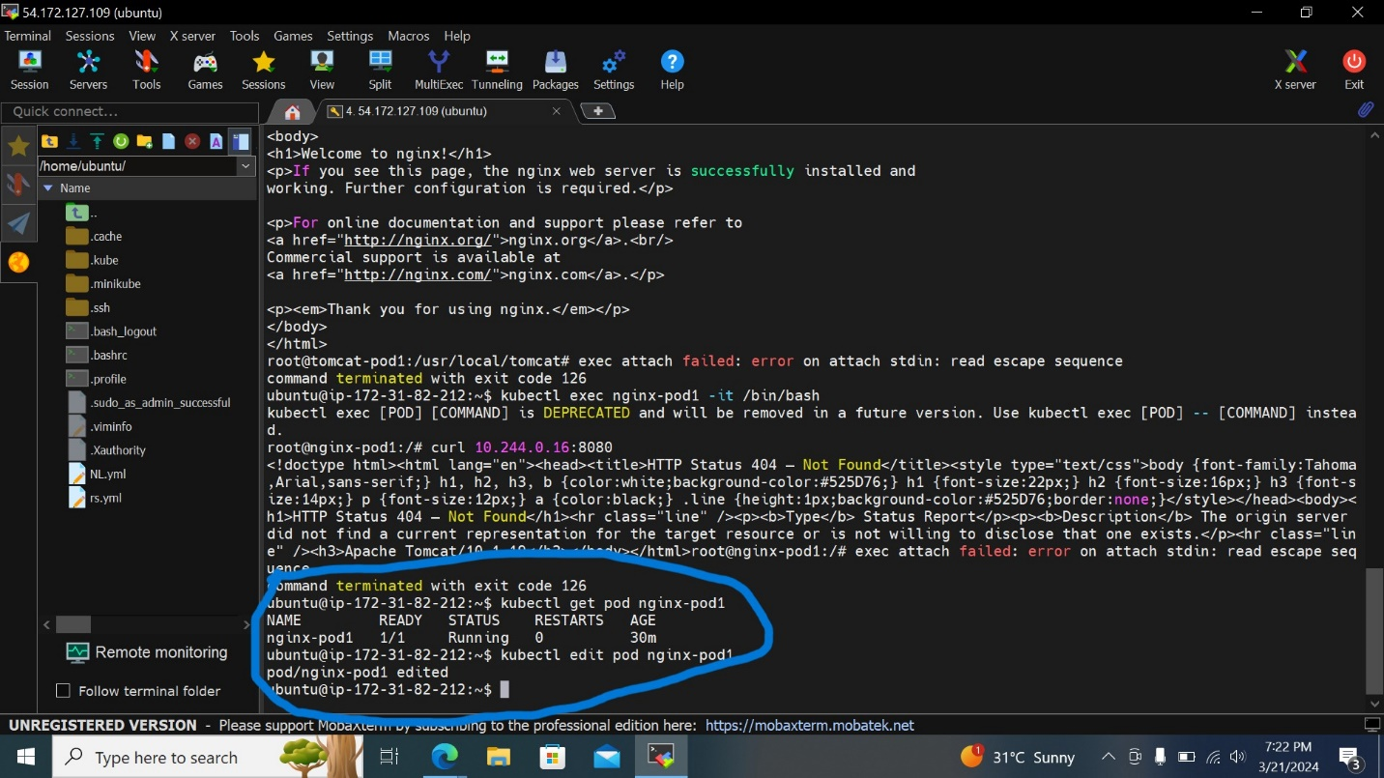

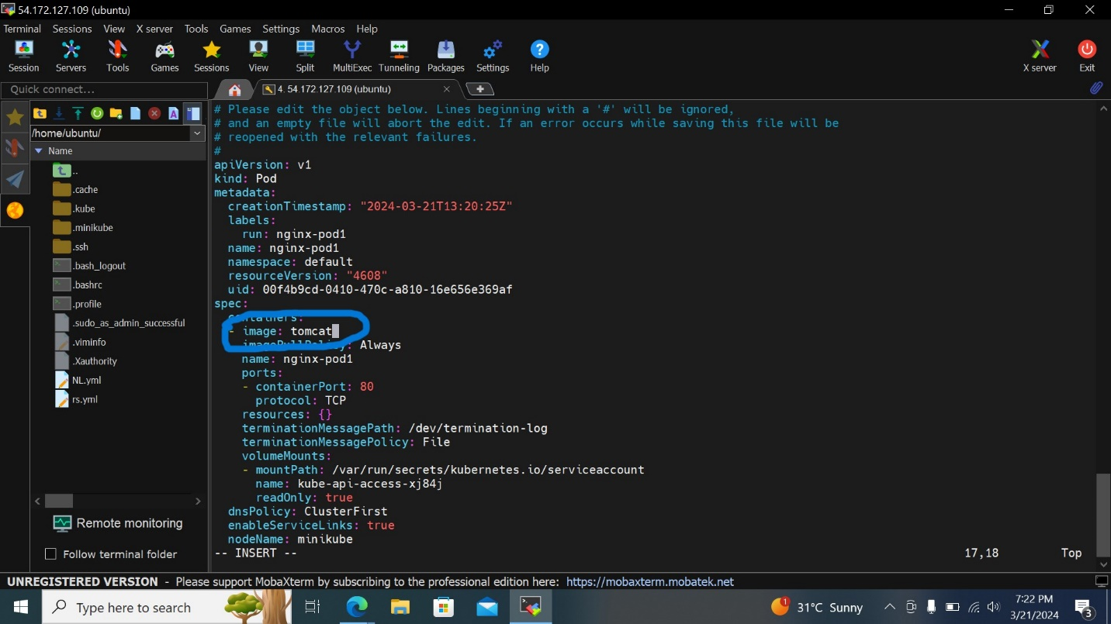

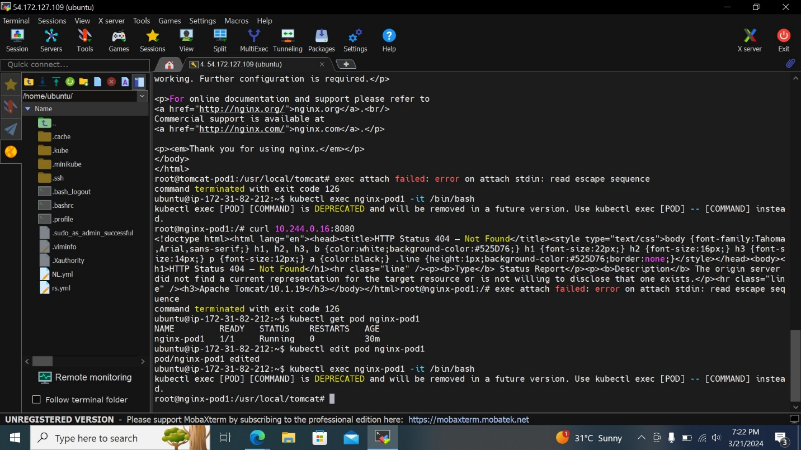



**7. Check the restart value of nginx-pod1.**

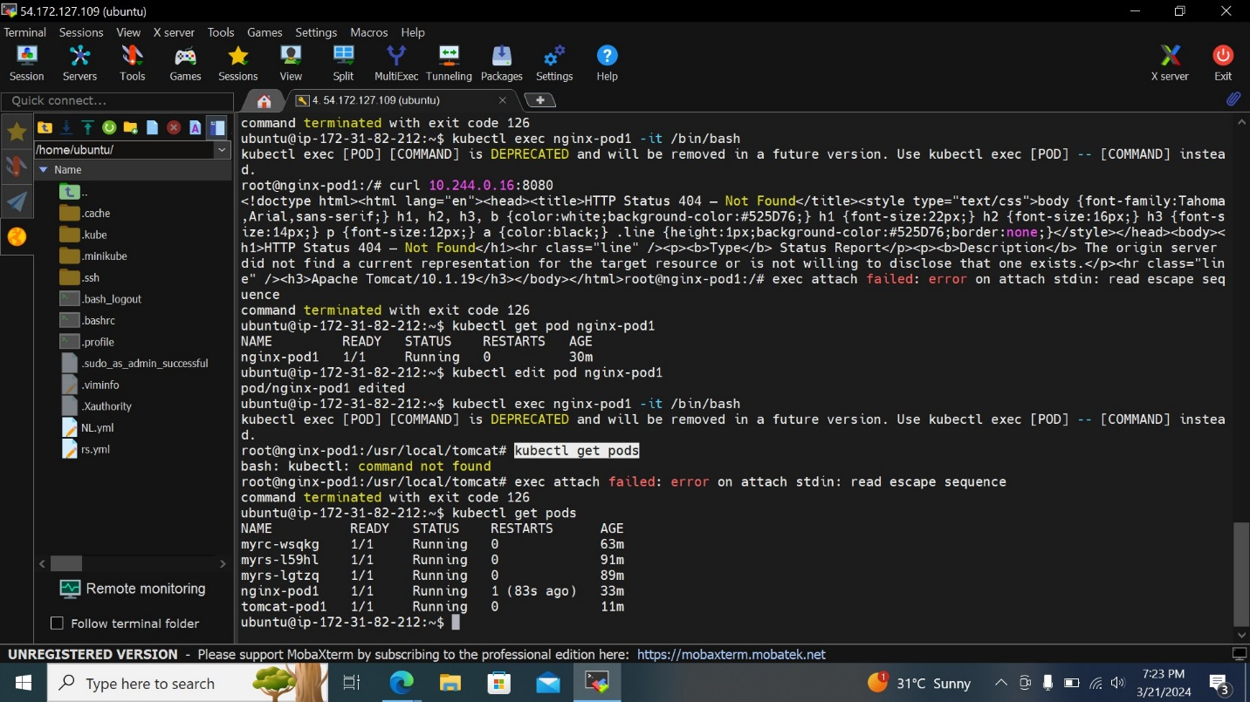



**8. check all the events of tomcat-pod1 and also find out in which namespace tomcat-pod1 is created.**

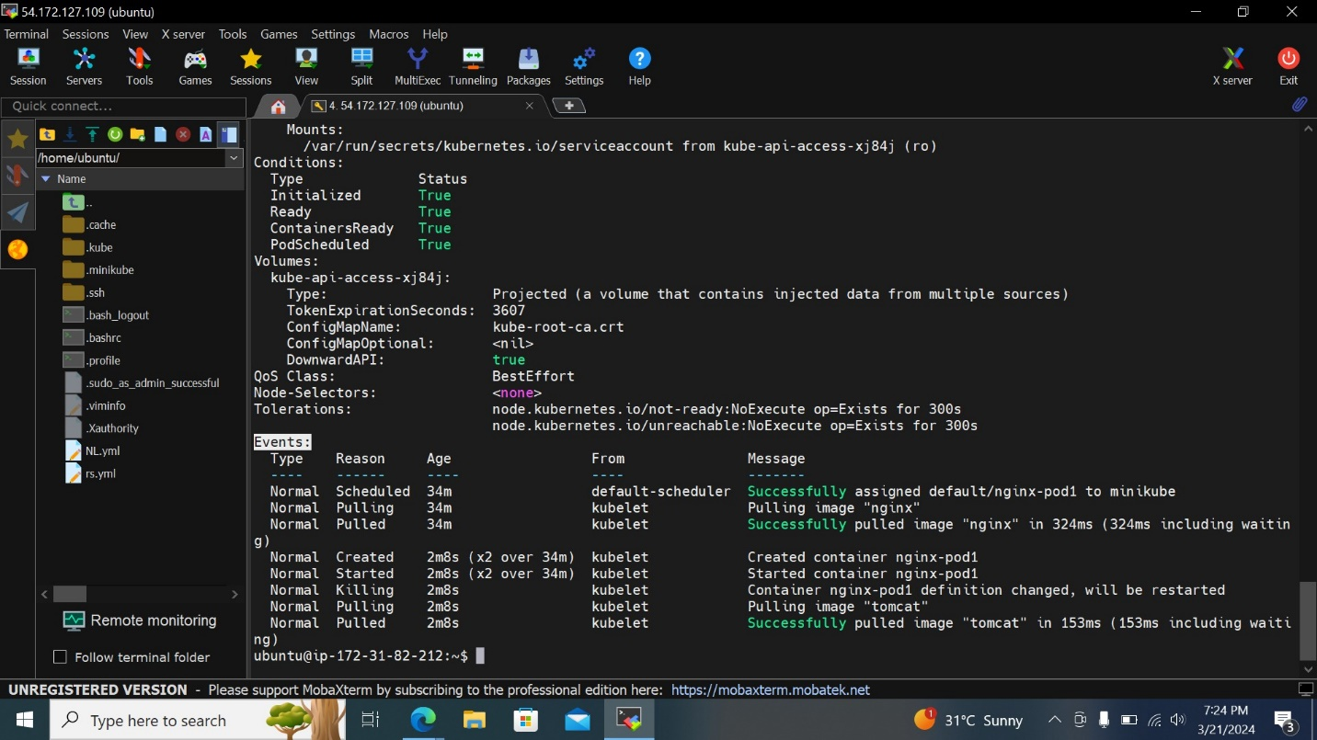

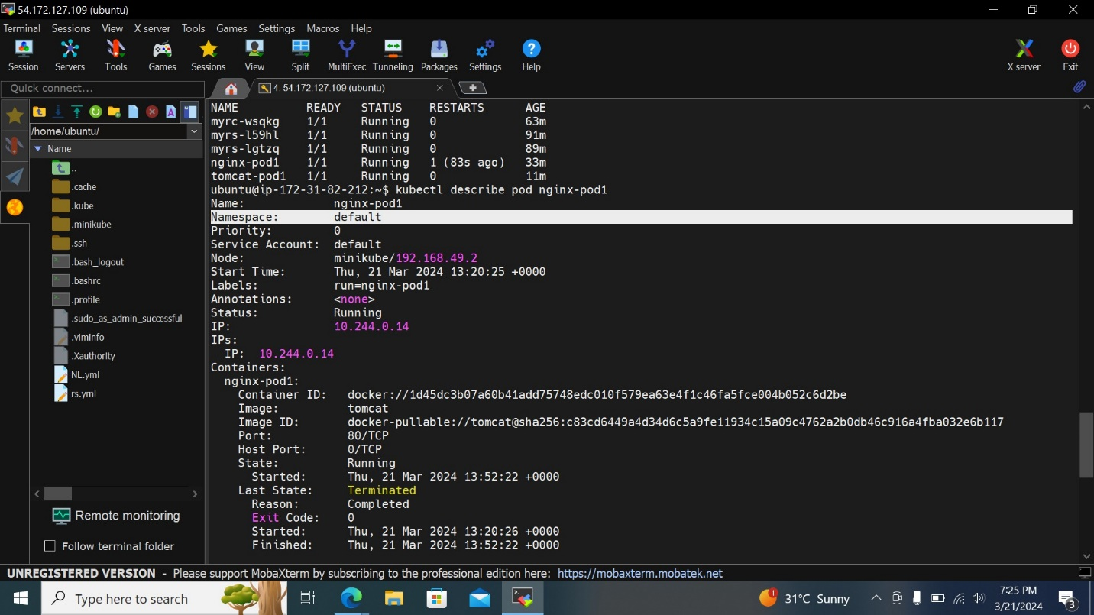

**9. Display the tomcat-pod1 properties in json format-- kubectl get pods -o=json**

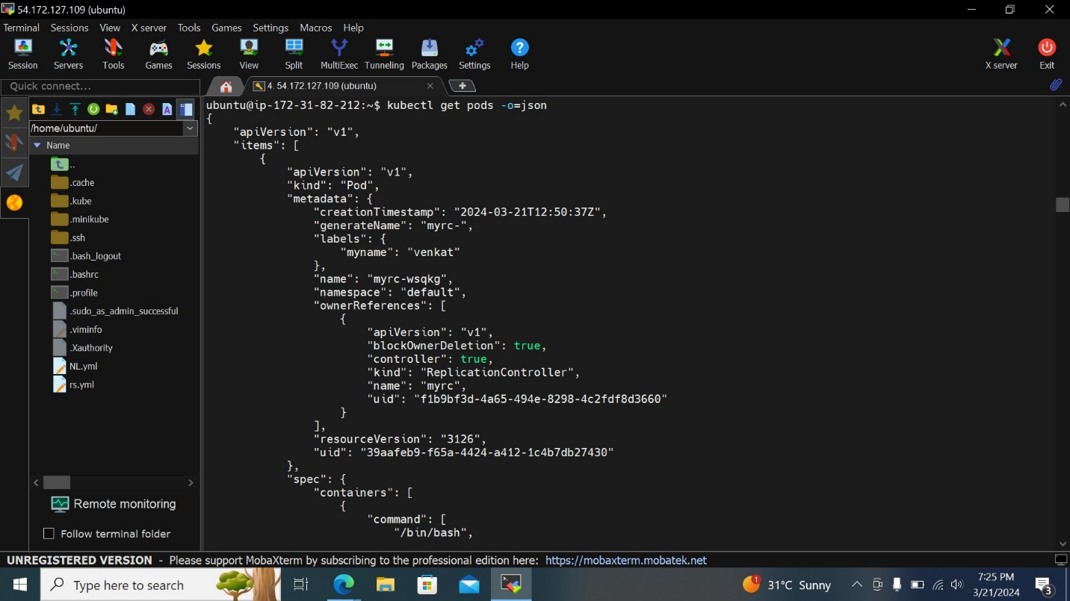

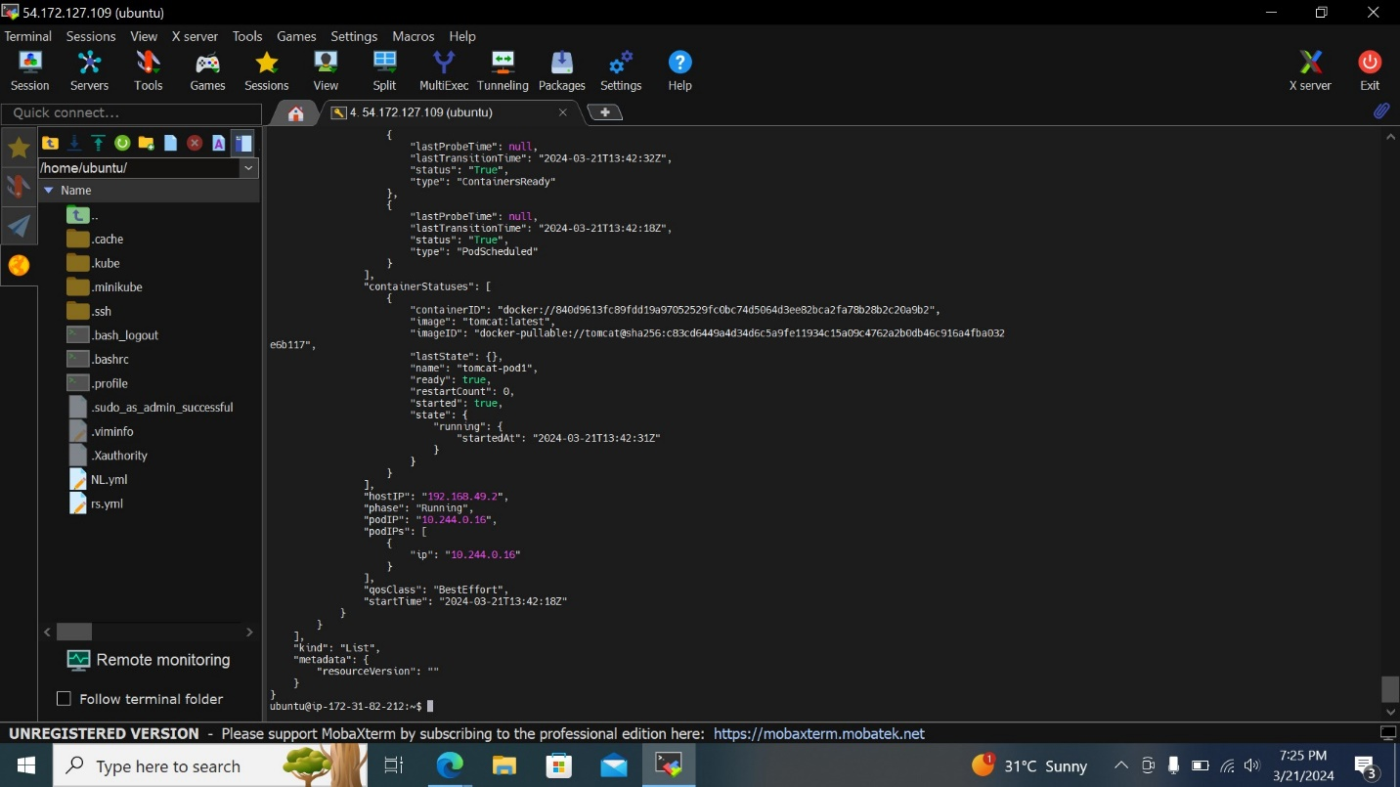

**10. Delete all the pods.**

